BRAND NEW MID-MARKET RENT PROPERTIES AVAILABLE!
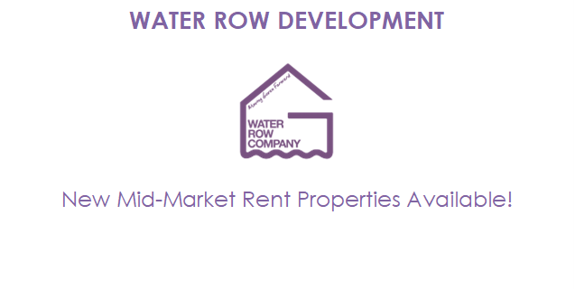
We have a very limited number of two-bedroom mid-market rent properties available immediately.
Please note that these properties will be allocated on a ‘first come, first served’ basis to applicants who meet the eligibility criteria.

Mid-Market Rent Homes Explained:
Mid-market rent homes are designed to assist those who are on low to modest incomes who are struggling to afford a privately rented property or to purchase a home of their own.

To be eligible for a mid-market rent home with the Water Row Company, you must be able to demonstrate affordability to pay the rent and are expected to earn a minimum of around £33,000 and no more than £54,000 per year (joint applicants can exceed this threshold by 20%).

If you are interested in applying for any of the properties at Water Row or would like further information, please contact us by emailing lettings@waterrow.co.uk

Council Tax Band C
EPC rating B

